CRUD API

🗂️ What is CRUD API
# Source: AI Source: Provided by: [Data Path: Persons Table -> ID Column: 1, Name_En Column: Motasem Essam] -> From: [ChatGPT] on [1/19/2026]
CRUD API refers to an API that provides basic operations to manage data in a system. The acronym CRUD stands for:
- C – Create → Add new data
- R – Read → Retrieve or fetch data
- U – Update → Modify existing data
- D – Delete → Remove data
👉 Think of a CRUD API as the standard interface to interact with your database or resources.

🔑 Key Concepts
# Source: AI Source: Provided by: [Data Path: Persons Table -> ID Column: 1, Name_En Column: Motasem Essam] -> From: [ChatGPT] on [1/19/2026]
- Resource-Based – Each CRUD API usually manages a resource (e.g., users, products)
- HTTP Methods Mapping – CRUD operations map to standard HTTP methods
- Stateless – Each request contains all necessary info to perform the action

🧱 HTTP Methods Mapping
# Source: AI Source: Provided by: [Data Path: Persons Table -> ID Column: 1, Name_En Column: Motasem Essam] -> From: [ChatGPT] on [1/19/2026]
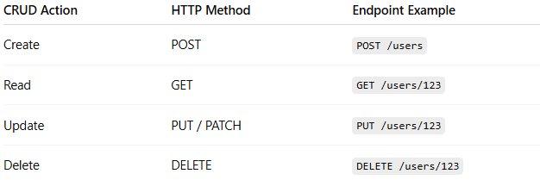
CRUD Action | HTTP Method | Endpoint Example
Create | POST | POST /users
Read | GET | GET /users/123
Update | PUT / PATCH | PUT /users/123
Delete | DELETE | DELETE /users/123

🧱 Example: Users Resource

1️⃣ Create (POST)
# Source: AI Source: Provided by: [Data Path: Persons Table -> ID Column: 1, Name_En Column: Motasem Essam] -> From: [ChatGPT] on [1/19/2026]
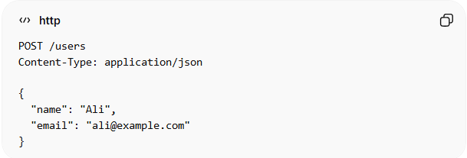
POST /users
Content-Type: application/json
{
"name": "Ali",
"email": "ali@example.com"
}
Response:
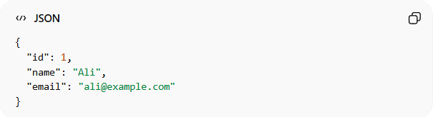
{
"id": 1,
"name": "Ali",
"email": "ali@example.com"
}

2️⃣ Read (GET)
# Source: AI Source: Provided by: [Data Path: Persons Table -> ID Column: 1, Name_En Column: Motasem Essam] -> From: [ChatGPT] on [1/19/2026]
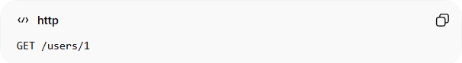
GET /users/1
Response:
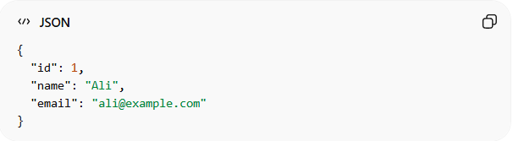
{
"id": 1,
"name": "Ali",
"email": "ali@example.com"
}

3️⃣ Update (PUT / PATCH)
# Source: AI Source: Provided by: [Data Path: Persons Table -> ID Column: 1, Name_En Column: Motasem Essam] -> From: [ChatGPT] on [1/19/2026]
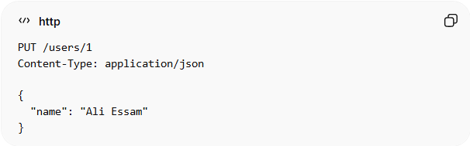
PUT /users/1
Content-Type: application/json
{
"name": "Ali Essam"
}
Response:
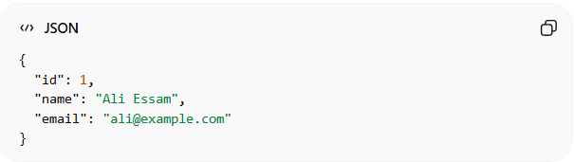
{
"id": 1,
"name": "Ali Essam",
"email": "ali@example.com"
}

4️⃣ Delete (DELETE)
# Source: AI Source: Provided by: [Data Path: Persons Table -> ID Column: 1, Name_En Column: Motasem Essam] -> From: [ChatGPT] on [1/19/2026]
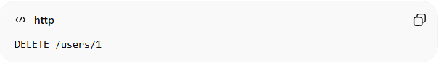
DELETE /users/1
Response:
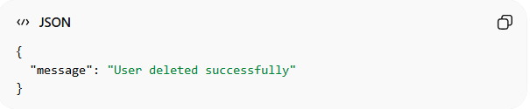
{
"message": "User deleted successfully"
}

⚙️ Notes
# Source: AI Source: Provided by: [Data Path: Persons Table -> ID Column: 1, Name_En Column: Motasem Essam] -> From: [ChatGPT] on [1/19/2026]
- PUT → replaces the entire resource
- PATCH → updates only specified fields
- CRUD operations are the foundation for REST APIs

✅ Best Practices
# Source: AI Source: Provided by: [Data Path: Persons Table -> ID Column: 1, Name_En Column: Motasem Essam] -> From: [ChatGPT] on [1/19/2026]
- Use proper HTTP status codes:
  - 201 Created for creation
  - 200 OK for read/update
  - 204 No Content for deletion
- Use consistent resource naming (/users, /products)
- Return meaningful responses
- Support filtering, sorting, and pagination on GET

💡 Summary
# Source: AI Source: Provided by: [Data Path: Persons Table -> ID Column: 1, Name_En Column: Motasem Essam] -> From: [ChatGPT] on [1/19/2026]
CRUD APIs provide a standard, predictable way to create, read, update, and delete resources, making them the backbone of most web and mobile applications.

